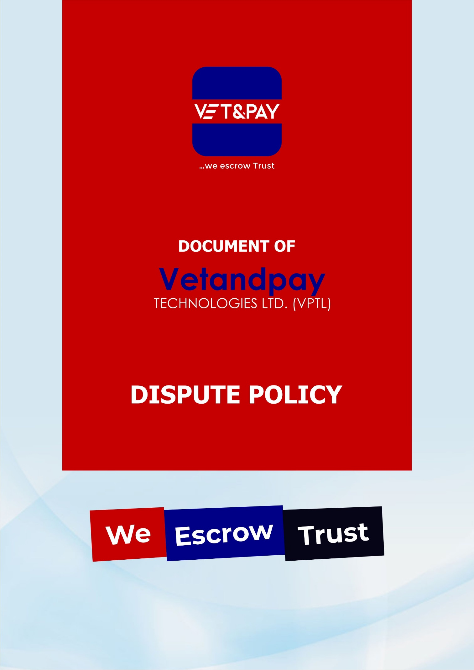
Dispute Resolution.
- If a dispute, claim, question, disagreement, or breach (collectively, “Disputes”) occurs between the Underlying Parties concerning the Escrow Transaction, or any aspect of the Escrow Services, the Underlying Parties shall promptly notify Vetandpay.ng in writing and use their best efforts during the Negotiation Period to resolve the Dispute. If they do so, they shall promptly notify Vetandpay.ng by joint instruction of the resolution terms. If they are unable to do so, they shall submit the matter to Arbitration on or before the Arbitration Commencement Period ends and promptly email notice of commencement to Vetandpay.ng. Before Buyer initiates Arbitration, Buyer must return the Merchandise to Seller.

- If any Dispute occurs between an Underlying Party and Vetandpay.ng or concerning the Escrow Services, the Parties agree to submit to binding Arbitration in accordance with this Section. An Underlying Party with such Dispute must promptly notify Vetandpay.ng of the Dispute in writing. The Underlying Party and Vetandpay.ng will use their best efforts during the Negotiation Period to resolve the Dispute. If the Parties are unable to resolve the Dispute during the Negotiation Period, they shall submit the matter to Arbitration on or before the Arbitration Commencement Period ends in accordance with this Section.
YOU AGREE AND ACKNOWLEDGE THAT YOU ARE GIVING UP YOUR RIGHT TO GO TO COURT to assert or defend your rights with respect to Vetandpay.ng to the maximum extent permitted by Applicable Law. You agree to resolve any Dispute between you and Vetandpay.ng EXCLUSIVELY THROUGH BINDING ARBITRATION as set forth in this Section. Your rights with respect to any Dispute with Vetandpay.ng will be determined by a NEUTRAL ARBITRATOR and NOT A JUDGE. You are entitled to a fair hearing, but the Arbitration procedures may be simpler and more limited than rules applicable in a court. You understand and agree that any final decision of an Arbitrator with respect to Arbitration between you and Vetandpay.ng is as enforceable as any court order.
Any Disputes brought by You must be brought exclusively in Your own capacity and not as a plaintiff or class member in any purported class or representative proceeding. Additionally, the Arbitrator may not consolidate more than one person’s Disputes against Vetandpay.ng and may not otherwise preside over any form of a representative or class proceeding or award class-wide relief against Vetandpay.ng.
- If Vetandpay.ng has not received notice of Arbitration following the Arbitration Commencement Period, Vetandpay.ng may terminate the Escrow Transaction and refund the Escrowed Funds to Buyer, minus the Escrow Fees. Vetandpay.ng may (but has no obligation to) commence Arbitration, or to interplead the Escrowed Funds with a court of competent jurisdiction. If so, Vetandpay.ng may use the Escrowed Funds to pay the fees to initiate Arbitration or to file an action and serve process except to the extent restricted or prohibited by Applicable Law. The Underlying Party Instituting Arbitration shall notify the other Parties by sending written notice of demand for arbitration. The Underlying Parties shall accept service of the notice of arbitration or a Complaint and summons in connection with a judicial action via email at the addresses previously provided to Vetandpay.ng by the Underlying Parties.

Arbitration may be initiated with the Nigerian Institute of Chartered Arbitrators (“NICarb”), at the discretion of the commencing Party. The Arbitration shall take place in Lagos and Abuja respectively, unless the involved Parties all agree to a different venue. The Arbitration will be subject to the Nigerian Arbitration and Mediation Act 2023
- and not any state arbitration law. Except as modified by these Terms, and unless otherwise agreed upon by the parties in writing, the Arbitration will be governed by the Arbitration Provider’s published rules and procedures. In the event of a conflict between these Terms and one of the Arbitration Provider’s rules or procedures, these Terms shall control to the extent of such conflict.
- Unless the involved Parties agree otherwise, Arbitration shall be conducted before a single neutral arbitrator who is a member of (NICarb) (“Arbitrator”) with substantial experience in resolving commercial contract disputes. The commencing Party shall provide the Arbitration Provider with a copy of this arbitration provision and the names, contact information, and contact persons associated with the Underlying Parties and Vetandpay.ng, with a copy to all other Parties (“Arbitration Request”). Vetandpay.ng shall not be a party to the Arbitration to resolve a Dispute between the Underlying Parties unless Vetandpay.ng voluntarily elects to participate. The Arbitration Request will request the Arbitration Provider to select an Arbitrator pursuant to the Arbitration Provider’s procedures. If the Arbitration Provider does not have such a procedure, the Arbitration Request will request the Arbitration Provider to identify three potential Arbitrators (“Arbitration Provider List”). No Underlying Party may request any specific Arbitrator be included on the Arbitration Provider List. Each Underlying Party may, within five (5) days after receipt of the proposed names, strike one name from the list. Thereafter, the Arbitration Provider shall appoint as Arbitrator a person whose name has not been struck and an alternate. If the Arbitration Provider does not timely appoint an Arbitrator and alternate, either Underlying Party may petition the high court of FCT Abuja and Lagos State respectively, for such appointment. Within ten (10) calendar days after the appointment, the Arbitrator shall schedule a planning hearing, which will be conducted by telephone and shall be held within the next ten (10) calendar days, to discuss scheduling, discovery, and any other issues in the Arbitrator’s discretion.
- The Arbitrator shall decide all gateway issues of arbitrability including whether the Dispute is subject to Arbitration in whole or in part and whether a Party’s litigation conduct constitutes a waiver of the right to demand Arbitration.
- The Arbitrator shall enter a default award if an Underlying Party fails to participate in the Arbitration.
- Unless the Underlying Parties (and Vetandpay.ng if involved) agree otherwise as set forth herein, the Arbitration for transactions shall take place in Lagos or Abuja, at a date, time and location selected by the Arbitrator. The final hearing must be commenced within 120 calendar days after notice of the selection of the Arbitrator is served (by either the Arbitration Provider or the Superior Court, as the case may be). The parties must use commercially reasonable efforts to have the hearing concluded within 90 calendar days after it is commenced, although the parties agree an Arbitrator may, in its sole discretion, take a longer period of time to set the time for the hearing or make its determination or order. A decision shall be reasoned. Except where the Arbitrator determines to take a longer period of time, the parties shall use commercially reasonable efforts to have the decision rendered within 20 days after the conclusion of the final hearing.
- Subject to the prevailing-party shifting award specified below, each Underlying Party shall advance a pro-rata share of the Arbitrator’s expenses and fees, and the other arbitration expenses incurred or approved by the Arbitrator. Vetandpay.ng will not be responsible for any portion of the Arbitration expenses and fees unless Vetandpay.ng is a party to a Dispute under paragraph (b) above. An Underlying Party that fails to pay its share shall not be allowed to participate in the Arbitration and shall be subject to an order of default and resultant award by the Arbitrator. If an Underlying Party fails to pay its share, the other Underlying Parties shall pay pro rata the remaining costs. The Arbitrator shall add such payment in the final award to return the Underlying Parties to their position had proper payment been made.

The Arbitrator shall award the prevailing Party his/her/its expenses and fees of Arbitration, reasonable attorneys’ fees, and witness fees in accordance with these Terms, and the Nigerian Arbitration and Mediation Act 2023
- and, as necessary, the applicable Arbitration Provider’s rules and procedures.
- A failure to respond or otherwise comply with a demand for Arbitration or to participate in the Arbitration will result in forfeiture of all rights of the non-complying Underlying Party concerning the dispute, including rights to the Escrowed Funds or any property associated therewith, and may result in a default judgment against that Underlying Party.
- An Arbitration award shall be final and binding upon the participating Parties to the Arbitration and judgment confirming the award may be entered in any court of competent jurisdiction. The Arbitrator shall serve a copy of the award on all Parties (including Vetandpay.ng even if not involved in Arbitration).
- Except as required by Applicable Law, Vetandpay.ng will take no action to close the Escrow Transaction or otherwise dispose of the Escrowed Funds until receipt of: (i) a joint instruction signed by all the affected Underlying Parties; or (ii) an order of the Arbitrator or court of competent jurisdiction directing action by Vetandpay.ng. Vetandpay.ng shall have no responsibility to initiate and/or continue to update the Underlying Parties regarding status of the Escrow Transaction, Arbitration, or judicial proceeding. If required by Applicable Law or if instructed by the Arbitrator, provided that all fees required of the Underlying Parties under these Terms are paid in advance, Vetandpay.ng will place the Escrowed Funds into an interest-bearing account. The disposition of the interest earned to the Underlying Parties shall be decided concurrently with the resolution of the dispute. THE OBLIGATION OF VETANDPAY.NG AND ITS AFFILIATES SHALL BE LIMITED TO THE HOLDING AND DISBURSEMENT OF THE ESCROW FUNDS UPON INSTRUCTIONS SIGNED BY ALL UNDERLYING PARTIES OR AN AWARD FROM THE ARBITRATOR AND/OR JUDGE. Notwithstanding any of the foregoing, Vetandpay.ng reserves the right at its sole discretion to interplead disputed funds related to any Escrow Transaction to a court.
- Vetandpay.ng may, in its discretion, institute Arbitration or a judicial proceeding (including interpleading the Escrowed Funds with a court of competent jurisdiction) to resolve any Dispute in an Escrow Transaction.

Vetandpay Technologies Limited (2025)

